PRACTICAL-5

Implementation of Lemmatization and Viterbi Algorithm

Lemmatization
Definition:
Lemmatization is a process in Natural Language Processing (NLP) that reduces a word to its base or dictionary form (lemma). Unlike stemming (which simply chops off word endings), lemmatization considers the morphological structure and grammar of the word.
Example:
- running, ran → run
- better → good
How Lemmatization Works
- It looks at Part-of-Speech (POS) (noun, verb, adjective, adverb) of the word.
- Uses vocabulary + morphological analysis to find the correct lemma.
- Often relies on lexicons like WordNet.
Types of Lemmatization
- Rule-Based Lemmatization
  - Uses linguistic rules (prefix/suffix rules, verb conjugation, pluralization rules).
  - Example:
    - “flies” (verb) → “fly”
    - “flies” (noun) → “fly”
  - Needs POS tagging to avoid ambiguity.
- Dictionary-Based Lemmatization
  - Uses a predefined dictionary/lexicon mapping words to their lemmas.
  - Example: WordNet Lemmatizer in NLTK.
  - Accurate but depends on dictionary coverage.
- Machine Learning Based Lemmatization
  - Combines rules + dictionary for better results.
  - Example: spaCy lemmatizer.
Difference from Stemming
- Stemming: “studies” → “studi” (just chopped)
- Lemmatization: “studies” → “study” (proper root word)

Viterbi Algorithm -
Definition:
The Viterbi algorithm is a dynamic programming algorithm used to find the most likely sequence of hidden states (called Viterbi path) in a Hidden Markov Model (HMM), given a sequence of observed events.
It is widely used in speech recognition, POS tagging, machine translation, and bioinformatics.
1. Transition Probability (aij​) -
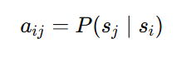
- Definition: The probability of moving from one hidden state si to another hidden state sj.
- Meaning:
If we are currently in state si​ at time t−1, this gives the likelihood of moving to state sj at time t.
2. Emission Probability (bj(ot​))
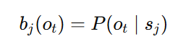
- Definition: The probability of observing a symbol (word, sound, etc.) given the current hidden state.
- Meaning:
If the hidden state is sj​, this gives the likelihood of generating observation ot​.

CODE:-
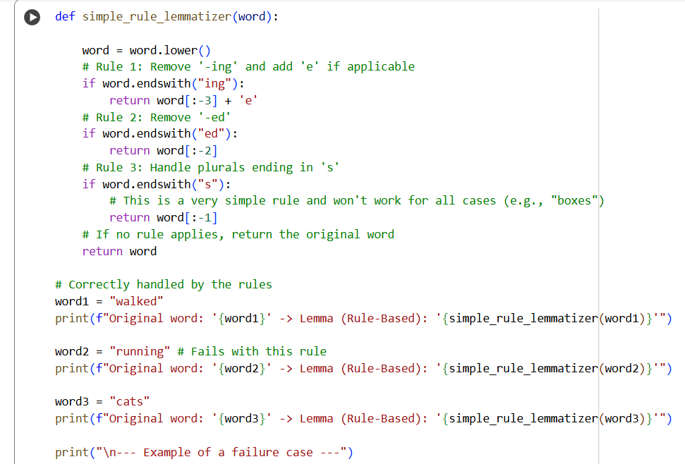
- Applying Rule-Based Lemmatization:

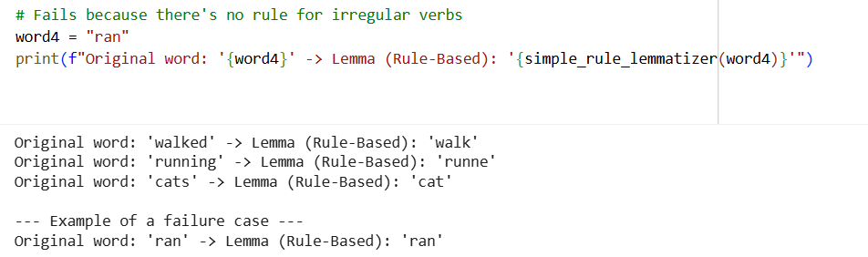
Output:

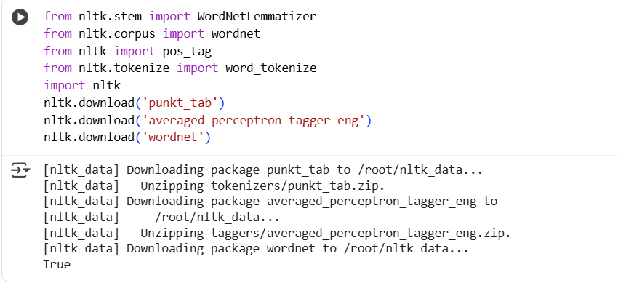
- Importing some libraries.

- Applying WordNet for Dictionary-Based Lemmatization:
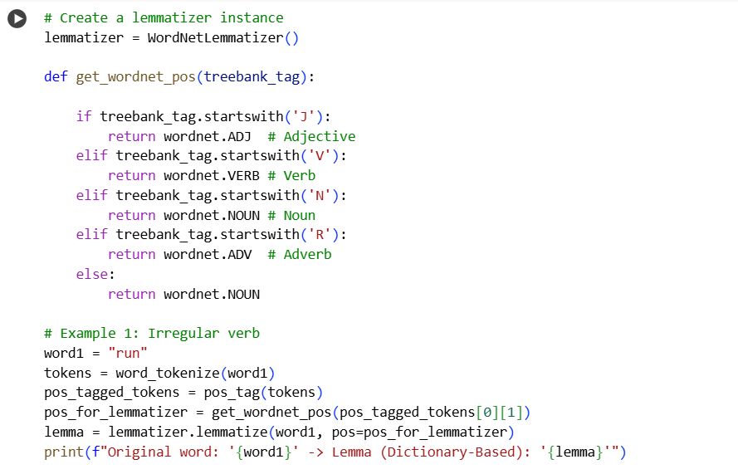

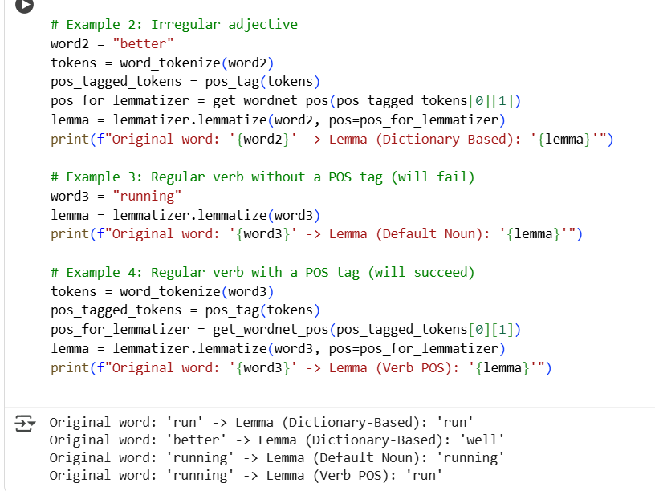

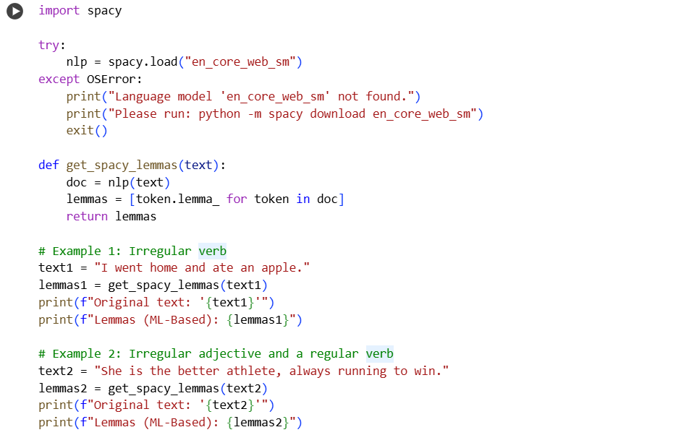
- Machine Learning Based Lemmatization –

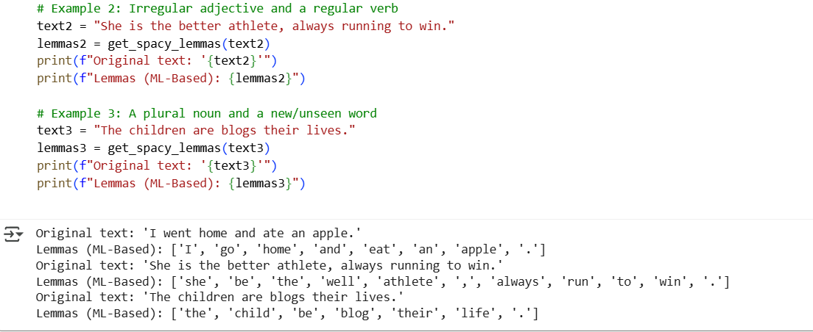

- Implementation of Viterbi Algorithm
